**Patient Information Sheet Today’s Date: ___________**

Patient Name:

Last First M.

Mailing Address (incl. city & zip):

Permanent Address (incl. city & zip):

Daytime Phone: ________________________ Ext. Evening Phone: __________________________

Date of Birth: _________________ SSN: ______________________________ Marital Status:

Current Employer: _________________________________________ Occupation:

(If workers’ comp, indicate employer where accident occurred)

Employer Address:

Date of Injury/Accident/Illness: ___________________________

Closest friend or relative not living with you:___________________________________________________________

Address: __________________________________________________________________________________________

Daytime Phone: _________________________Ext: _________Evening Phone:

## **Insurance Information**

Primary Insurance Company:

Subscriber’s Relationship to Patient: SELF SPOUSE PARENT OTHER

Spouse Name:

Last First M.

Spouse’s Employer: _____________________________________________ Telephone #

Spouse SSN: _________________________________Spouse Date of Birth:_______________________________

Secondary Insurance Company:

Third Insurance, if applicable:

## **Referral Information**

## (Please tell us how you were referred to our practice)

Referring Physician_____________________________ Health Plan Provider List ________________________

Other Source_____________________________________(W/C Adjuster, Case Manager, Website, Friend etc.)

**Please read the following authorization. Initial and sign below for our files.**

___________ I understand that any appointment changes must be made at least 24 hours in advance or a $30 fee will be applied.

**Signature_________________________________________________ Date**

**\*\*\* Please present this form and all insurance ID cards to the receptionist at this time. \*\*\***

I, the undersigned, do hereby agree and give my consent for ***TAMPA PAIN RELIEF CENTER*** to furnish medical care and treatment to myself, _________________________________________________ considered necessary and proper in diagnosing or treating my/his/her physical and mental condition.

Patient/Guardian/Responsible Party____________________________ Date ________________________

**Patient Name** ___________________________________ Date of Birth _______________ Age _________

Gender: ***(Please circle)*** Male / Female Race: ***(Please circle)*** White / Black / Hispanic / Asian / Other ______

Who referred you to us? _______________________ Who is your Family Doctor? _______________________

Is your visit related to an injury? YES/NO If Yes, specify: AUTO Work Comp OTHER

Have you been to any previous pain management? Yes or No (***circle one***)

Name of Physician(s) ____________________________________________________________________

WORK STATUS: ____ Regular Duty _____ Light Duty, Restrictions ____________________________________

___ Off Work: last worked: ________________

___ Disabled: since __________________ by what doctor _________________________________________

___ Retired: since what year _________

Location of Pain: ______________________________________________________________________________

**In the diagram below, please shade the areas of your pain**

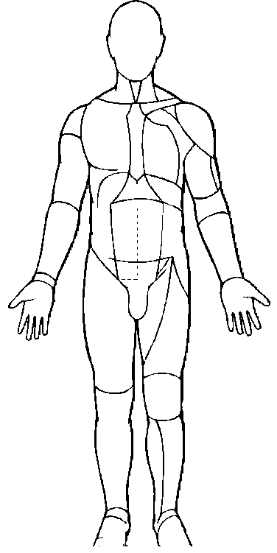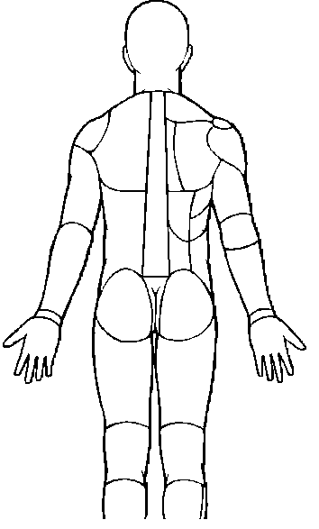

(***Circle your answer***)

Pain Scale: From 0 – 10 what is your pain level today?

(NO PAIN) **0 1 2 3 4 5 6 7 8 9 10** (WORST PAIN)

What is your range of pain in the past month?

(NO PAIN) **0 1 2 3 4 5 6 7 8 9 10** (WORST PAIN)

What treatments have you had for your pain? Check all that apply.

|  |  |  |
| --- | --- | --- |
| __ Physical Therapy | __ Favorable Results | __ Poor Results |
| __ Acupuncture | __ Favorable Results | __ Poor Results |
| __ Chiropractor | __ Favorable Results | __ Poor Results |
| __ Trigger Point Injections | __ Favorable Results | __ Poor Results |
| __ TENS Unit | __ Favorable Results | __ Poor Results |
| __ Nerve Blocks | __ Favorable Results | __ Poor Results |
| Type of Nerve Block | _________________________________ | |

___Back or Neck Surgery Type________________________________ When __________________

___Spinal Cord Stimulator Type________________________________ Date implanted __________

___Morphine Pump Type _______________________________ Date implanted __________

___Other: ____________________________________________________________________________________

|  |  |  |  |
| --- | --- | --- | --- |
| **Allergies:** | _____________________ | _____________________ | _____________________ |
| _____________________ | _____________________ | _____________________ | _____________________ |

**Patient History:** (check each that apply)

|  |  |  |  |
| --- | --- | --- | --- |
| Tobacco: | ___ do not smoke | ___ smoke | ___ pack(s) per day |
| Alcohol: | ___ do not drink | ___ drink | # of drinks per ____ day ____ week |

ILLEGAL DRUG USE Denies Any Illegal Drug Use Currently Using Illegal Drugs (Which __________________________)

Currently Uses Marijuana Currently Uses Someone Else’s Prescription Medications

Formerly Used Illegal Drugs (not currently using) (Which ______________________________________)

Have you ever abused narcotic or prescription medications? Yes No (Which ______________________________)

Are there any substance abuse issues in your household? Yes No

|  |  |  |  |  |  |  |  |  |
| --- | --- | --- | --- | --- | --- | --- | --- | --- |
| Social History: | ___ Married | | | ___ Single | ___ Divorced | | | |
| Lives With: | ___ Spouse | | | ___ Children | ___ Other ____Alone | | | |
|  |  | | |  |  | | | |
| ___Blind | | ___Glasses | ___Contacts | | | ___Hard of Hearing | ___Deaf | ___HIV+ |
| ___Hearing Aids | | ___Cancer | ___Thyroid Disease | | | ___Gallbladder Disease | ___Birth Defects | |

Under each Category, please check any symptoms that apply

|  |  |  |  |  |  |
| --- | --- | --- | --- | --- | --- |
| **Cardiovascular** | | **Gastrointestinal** | **Neurological** | **Musculoskeletal** | **Psychiatric** |
| ___Hypertension (High) | | __Chronic Diarrhea | __Migraines | __Arthritis | ___Depression |
| ___Hypotension (Low) | | __Chronic Constipation | __Frequent Headaches | __Osteoarthritis | ___Anxiety Disorder |
| ___Anemia | | __Incontinence | __Epilepsy | __Rheumatoid | ___Bipolar |
| ___Heart Disease | | __Ulcers | __Sleeping Disorders | __Low Back Syndrome | ___Alcoholism |
| ___Stroke | | __Hepatitis | __Restless Leg | __Cane | ___Drug Addiction |
| ___Swelling of Feet | | __Ulcers | Syndrome | __Walker | ___Suicide Attempt |
| ___Chest Pain | | __Liver Disease | __Other:__________ | __Wheelchair | ___Schizophrenia |
| ___Shortness of Breath | | __Diabetes |  | __Prosthesis | ___Other:________ |
| ___Rheumatic Fever | | __Gout |  | Type:___________ |  |
|  | | __Other:__________ |  | __Other:__________ |  |
| **Genitourinary:** | |  | **Respiratory:** |  |  |
| **___** Urinary Incontinence | | | **___** Asthma |  |  |
| ___Kidney Disease |  | | ___ COPD |  |  |
| ___Other:__________ |  | | ____Chronic Cough |  |  |
| __________________ |  | | ____O2 Therapy |  |  |

Medications you are presently taking: **Include Over the Counter & prescription drugs**.

Pain Medications, Muscle Relaxants, Sleep Aid, Anti-anxiety, and Antidepressants.

Medications Dose Frequency (use back of paper if needed)

________________________________________________________________________________________________________________________________________________________________________________________________________________________________________________________________________________________________________________________________________________________________________________________________________________________________________________________________________________________________

SURGERIES DATE (month/year)

(Please list below)

________________________________________________________________________________________________________________________________________________________________________________________________________________________________________________________________________________________________________________________________________________________________________

FAMILY HISTORY

Relation Current State of Health & History of Problems

­­­­­­­­­­­­­Mother _________________________________________________________________________________________________________________

Father _________________________________________________________________________________________________________________

Siblings ________________________________________________________________________________________________________________

**Intake Form**

**Height: _______ Weight:______ BP: ______/_______ ♥:______**

**How many years/months ago did the main area of pain start? ____________________**

**Please CIRCLE any symptoms that you have experienced in the last year or since your last visit:**

**Constitutional: Gastrointestinal: Integumentary:**

Chills Abdominal Pain Hair Loss

Fatigue Blood in Stools Rashes

Night Sweats Constipation

Weight Gain Diarrhea **Psychiatric:**

Weight Loss Heartburn Anxiety / Depression

Weight Loss Loss of Appetite Insomnia

Nausea

**HEENT:** Vomiting  **Metabolic:**

Ear Drainage Cold Intolerance

Ear Pain **Genitourinary:** Heat Intolerance

Eye Discharge Blood in Urine Excessive Thirst

Eye Pain Urine Frequency Increased Hunger

Hearing Loss Urine Incontinence

Nasal Drainage Urinary Retention **Musculoskeletal:**

Sinus Pressure Back Pain

Sore Throat **Reproduction:** Joint Pain

Visual Changes Erectile Dysfuntion Joint Swelling

Penile/Vaginal Discharge Muscle Weakness

**Respiratory:** Hot Flashes Neck Pain

Cough Irregular Menses

Known TB exposure Abnormal Pap  **Hematologic:**

Shortness of Breath Bleed Easily

**Neurological:** Bruise Easily

**Cardiovascular:** Dizziness Swollen Lymph Nodes

Chest Pain Extremity Numbness

Claudication Extremity Weakness  **Immunologic:**

Edema Headaches Seasonal Allergies

Palpitations Memory Loss Food Allergies

Seizures

Tremors

Have you had any change to your medical history since your last visit? **NO YES _________________**

Have you had any change to your social history since your last visit? **NO YES ____________________**

Have you added or changed any medications since your last visit? **NO YES ______________________**

Have you had any other changes since your last visit? **NO YES _______________________________**

**ON THE DIAGRAM BELOW – PLEASE MARK WHERE YOUR PAIN IS LOCATED:**

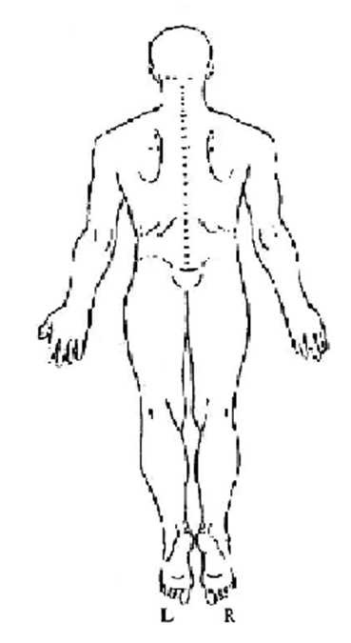 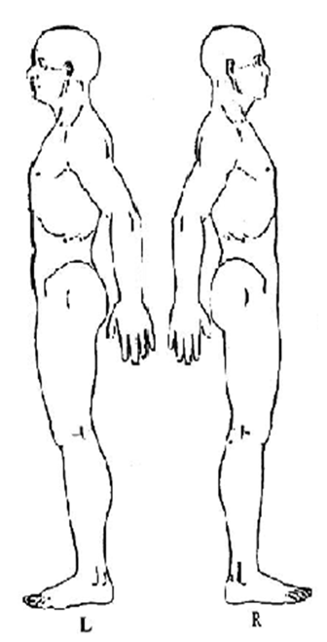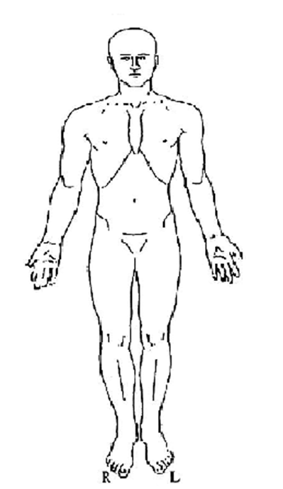

**DESCRIBE YOUR PAIN: WHAT MAKES YOUR PAIN WORSE: WHAT MAKES YOUR PAIN BETTER:**

**** Aching  Nothing  Nothing

▪ Burning  Stairs  Heat

▪ Discomfort  Changing Position  Ice

▪ Dull  Daily Activities  Injections

▪ Gnawing  Jumping  Lying Down/Rest

▪ Numbness  Lifting  Massages

▪ Piercing  Lying Down/Rest  Movement

▪ Sharp  Rolling Over in Bed  Anti-inflammatory Meds

▪ Shooting  Sitting  Pain Meds/Drugs

▪ Stabbing  Standing  Physical Therapy

▪ Throbbing  Walking  Exercise/Stretching

▪ Tingling  Weather

Other: _________________ Other: ___________________ Other: __________________

**CURRENT PAIN LEVEL ______ / 10**

Any procedures since your last visit? ** Yes  No If yes: Relief? ____________________%**

**PHYSICIAN/PATIENT INFORMED CONSENT AND AGREEMENT FOR LONG-TERM OPIOID/NARCOTIC THERAPY FOR TREATMENT OF CHRONIC PAIN FORM**

**PATIENT: ________________________________________ DATE: _________________**

You have agreed to receive opioid/narcotic therapy for the treatment of chronic pain. You understand that these drugs are very useful, but have potential for misuse and are therefore closely controlled by local, state, and federal governments. The goal of this treatment is to: (a) reduce your pain; and (b) improve your level of function in performing your activities of daily living.

* Alternative therapies and medications have been explained and offered to you. You have chosen opioid/narcotic therapy as one component of treatment.

The use of cigarettes demonstrates a dependence of nicotine. This complicates opioid therapy. If you are a smoker, you have agreed to a smoking cessation program.

You must be aware of the potential side effects and risks of these medications. They are explained below. If you have any questions or concerns during the course of your treatment, you should contact your physician.

**SIDE EFFECTS**

Side effects are normal physical reactions to medications. Common side effects of opioid/narcotics include mood changes, drowsiness, dizziness, constipation, nausea, and confusion. Many of these side effects will resolve over days or weeks. Constipation often persists and may require additional medication. If other side effects persist, different opioid may be tried or they may be discontinued.

You should NOT:

1. Operate a vehicle or machinery if the medication makes you drowsy;
2. Consume ANY alcohol while taking opioids /narcotics; or
3. Take any other non-prescribed sedative medication while taking opioids/narcotics.

The effects of alcohol and sedatives are additive with those of opioids/narcotics. If you take these substances in combination with opioids/narcotics, a dangerous situation could result, such as coma, organ damage, or even death.

Driving while taking opioids for chronic pain is considered medically acceptable as long as you do not have side effects such as sedation or altered mental status. The side effects usually do not occur while taking opioids/narcotics chronically. However, it is **possible** that you could be considered DUI if stopped by law enforcement while driving.

Opioids have also been known to cause decreased sexual function and libido. This is due to their effects on suppression of certain hormones such as testosterone and DHEA which can cause these side effects. Your hormone levels can be monitored during your treatment.

Constipation is a well-known side effect of opioid therapy and can usually be treated with stool softeners or gentle laxatives. Constipation is a side effect that usually does not go away and requires treatment.

**PATIENT’S INITIALS: _____**

**RISKS**

**Dependence**

Physical dependence is an expected side effect of long-term opioid/narcotic therapy. This means that if you take opioids/narcotics continuously, and then stop them abruptly, you will experience a withdrawal syndrome. This syndrome often includes sweating, diarrhea, irritability, sleeplessness, runny nose, tearing, muscle and bone aching, gooseflesh, and dilated pupils. Withdrawal can be life-threatening. To prevent these symptoms, the opioids/narcotics should be taken regularly or, if discontinued, reduced gradually under the supervision of your physician.

**Tolerance**

Tolerance to the pain-relieving effect of opioids/narcotics is possible with continued use. This means that more medication is required to achieve the same level of pain control experienced when the opioid/narcotic therapy was initiated. When tolerance does occur, sometimes it requires tapering or discontinuation of the opioid/narcotic. Sometimes tolerance can be treated by substituting a different opioid/narcotic. When initiated, doses of medication must be adjusted to achieve a therapeutic, pain relieving effect; upward adjustments during this period are not viewed as tolerance.

**Increased Pain (Hyperalgesia)**

The long-term effects of opioids/narcotics on the body’s own pain-fighting systems are unknown. Some evidence suggests that opioids/narcotics may interfere with the pain modulation, resulting in an **increased** sensitivity to pain. Sometimes individuals who have been on long-term opioids/narcotics, but who continue to have pain, actually note decreased pain after several weeks off of the medications.

**Addiction**

Addition is a primary, chronic, neurobiological disease, with genetic, psychosocial, and environmental factors influencing the development and manifestations. It is characterized by behaviors that include one or more of the following:

* Impaired control over drug use;
* Compulsive use;
* Continued use despite harm; and/or
* Craving

Most patients with chronic pain who use long-term opioids/narcotics are able to take medications on a scheduled basis as prescribed, do not seek other drugs when their pain is controlled, and experience improvement in their quality of life as the result of opioid therapy. Therefore, they are **NOT** addicted. **Physical dependence** is **NOT** the same as addiction.

**Risk to Unborn Children**

Children born to women who are taking opioids/narcotics on a regular basis will likely be physically dependent at birth. Women of childbearing age should maintain safe and effective birth control while on opioid/narcotic therapy. Should you become pregnant, immediately contact your physician and the medication will be tapered and stopped.

**PATIENT’S INITIALS: _____**

**Long-Term Side Effects**

The long-term effect of opioid/narcotic therapy is not fully known. Most long-term effects have been listed above. If you have additional questions regarding the potential long-term effects of opioid/narcotic therapy, please speak with your physician.

**PRESCRIPTIONS AND USE OF OPIOID/NARCOTIC MEDICATIONS**

Your medication will be prescribed by your physician for control of pain. Based on your individual needs, you will be provided with enough medication on a monthly basis, two-month basis, or three-month basis. New injuries or pain problems will require reevaluation. Prescriptions for opioids/narcotics will **not** be “called in” to the pharmacy.

**You agree that you must be seen by your physician at the interval directed by your physician, at a minimum of every three months, during the course of your therapy.**

**You agree** and understand that increasing your dose without the close supervision of your physician could lead to drug overdose, causing severe sedation, respiratory depression, and/or death.

**You agree** and understand that opioid/narcotic medication is strictly prescribed for you, and your opioid/narcotic medication should **NEVER** be given to others.

**You agree** to fill opioid/narcotic prescriptions at one pharmacy.

**You agree** to secure your opioid/narcotic medications in safe, locked source to prevent loss or theft. You are responsible for any loss or theft.

**You agree** that lost, stolen, or destroyed prescriptions or drugs **will not** be replaced, and may result in discontinuation of treatment.

**You agree** to obtain opioid/narcotic medication from one prescribing physician or that physician’s substitute if your prescribing physician is not available and your prescribing physician has authorized his or her substitute to provide treatment.

**You agree** to submit to an initial examination and evaluation, to routine examination and evaluation on a monthly basis or regular basis (but no less than every three months), and to examination and evaluation at the direction of your physician.

**You agree** to submit to blood and/or urine testing to monitor the levels of medication or other drugs and any organ side effects. **You also agree** that other doctors and law enforcement may be notified of the results.

**You agree NOT** to call the physician for refills or replacement medications during evening hours or on weekends/holidays. Medication refill and/or replacement requests will be addressed during regular business hours only.

**You understand and agree** that if you lose your medication or run out early due to overuse, you may experience and go through withdrawal from opioids/narcotics. **You further understand and agree that you are solely responsible for your own medication.**

**You agree** to bring all prescription medications in their bottles or containers to the office during regularly scheduled visits.

**PATIENT’S INITIALS: _____**

**You agree** to provide a list from your pharmacy detailing all medications received from that pharmacy and to provide updated lists as requested by your physician.

**For patients taking methadone**: Methadone has significant interactions with many other medications. Some of these medications may reduce your body’s ability to metabolize methadone, thus **INCREASING** the methadone in your body, which could be dangerous. Therefore, you **MUST** notify this office of **ALL** medications prescribed for **ANY** condition while taking methadone.

**OPIOID/NARCOTIC THERAPY MAY BE DISCONTINUED IF YOU:**

* Develop progressive tolerance which cannot be managed by changing medications;
* Experience unacceptable side effects which cannot be controlled;
* Experience diminishing function or poor pain control;
* Develop signs of addiction;
* Abuse any other controlled substance (this may be determined by random blood/urine testing);
* Obtain and or use street drugs (this may be determined by random blood/urine testing);
* Increase your medications without the consent of your physician;
* Either refuse to stop or resume smoking;
* Obtain opiates/narcotics from other physicians or sources;
* Fill prescriptions at other pharmacies without explanation;
* Sell, give away, or lose medications;
* Fail to submit to routine examination and evaluation on a monthly basis or regular basis (but no less than once every three months), or as directed by your physician;
* Fail to bring your prescription medications to your regularly scheduled visits;
* Fail to submit to blood/urine testing as directed;
* Call for refills during evenings, weekends or holidays; or
* Violate any of the terms of this agreement.

By signing below, I acknowledge and agree that: (i) I have read and fully understand the Physician/Patient Informed Consent and Agreement for long-term opioid/narcotic therapy for the treatment of chronic pain, (ii) I have been given the opportunity to ask questions about the proposed treatment (including no treatment), potential risks, complications, side effects, and benefits; (iii) I knowingly accept and agree to assume the risks of the proposed treatment as presented; and (iv) I agree to abide by the terms of this agreement.

**Patient Signature: ___________________________ Date __________**

**Print Name: ___________________________**

**Witness Signature ____________________________ Date __________**

**Print Name: ____________________________**

**Urine Toxicology Screen Policy**

This notice is to inform all patients as to why you have been asked to give a urine specimen and information regarding billing of the specimen.

A prescribing provider may collect a patient urine/oral specimen in the office and send the specimen to a certified laboratory. Alternatively, the patient may be sent directly to the laboratory with orders for provision of a sample.

The physician and clinical staff shall follow the collection process required by clinic procedural policy, and the agreement the pain management clinic has entered into with the certified laboratory(ies) it uses.

Surgery Partners Physicians shall ensure that it maintains chain-of-custody of the urine or oral fluid specimen once received from the patient up until the specimen testing is completed by the in-office laboratory or shipped to an off-site laboratory for testing.

In an effort to deter Pill Mill activity, in January 2010, the State of Florida changed rules and laws pertaining to all pain management practices or clinics. **Florida Rule: 64B8-9.0131** was passed by the Florida House and all “pain management “practices must be in compliance. This rule states that all patients receiving care must be tested at a minimum of twice yearly to ensure that there are no inconsistencies, and/or medications that you are taking are being metabolized in an effective manner, in order to better treat your pain. Unfortunately, **this testing is to be done whether you are being prescribed no medication or multiple medications**. If there are inconsistencies in your results, it is up to the physician/practitioner to retest randomly as needed.

Florida pain understands that this testing may come as an added expense to you, and we do apologize for any inconvenience this may cause. We will make every effort to keep your expenses down and still maintain our contracts with you insurance carrier, as to keep claims “in network”, with your insurance. Therefore, it is important to confirm correct insurance information at every office visit, to ensure that your claim is filed properly. Florida Pain makes every effort to provide accurate insurance information, but sometimes your outgoing information may be incorrect or not updated. Please verify your insurance information with our staff at every visit which may reduce any issues and resolve questions directly with the outside laboratories.

__________________________________________

Print Name of Signer

_______________________________________ _____________________

Signature Date

**PATIENT FINANCIAL RESPONSIBILITY FORM**

Thank you for choosing _____________________ as your healthcare provider. We are honored by your choice and are committed to providing you with the highest quality healthcare. We ask that you read and sign this form to acknowledge your understanding of our patient financial policies.

***Patient Financial Responsibilities***

* The patient (or patient’s guardian, if a minor) is ultimately responsible for the payment for her treatment and care.
* We are pleased to assist you by billing for our contracted insurers. However, the patient is required to provide us with the most correct and updated information about their insurance, and will be responsible for any charges incurred if the information provided is not correct or updated.
* Patients are responsible for the payment of co-pays, co-insurance, deductibles, and all other procedures or treatment not covered by their insurance plan. Payment is due at the time of service, and for your convenience, we accept cash, check, and most major credit cards at our office.
* Patients may incur, and are responsible for the payment of additional charges at the discretion of TPRC, DBA Florida Pain Institute. These charges may include (but are not limited to):
  + Charge for returned checks.
  + Charge for missed appointments without 24 hours advance notice
  + Charge for extensive phone consultations and/or after-hours phone calls requiring diagnosis, treatment, or prescriptions.
  + Charge for the copying and distribution of patient medical records.
  + Charge for extensive forms completion.
  + Any costs associated with collection of patient balances.

***Patient Authorizations***

* By my signature below, I hereby authorize TPRC, DBA Florida Pain Institute and the physicians, staff, and hospitals associated with TPRC, DBA Florida Pain Institute to release medical and other information acquired in the course of my examination and/or treatment (with the exceptions stipulated below) to the necessary insurance companies, third party payers, and/or other physicians or healthcare entities required to participate in my care.
* I understand that I must check one or more of the following types of health information to indicate that I authorize that information type to be released to the necessary insurance companies, third party payers, and/or other physicians and/or healthcare entities required to participate in my care. By checking one or more of the following boxes, the health information I authorize to be released may include any of the following:
  + Diagnosis, evaluation, and/or treatment for alcohol and/or drug abuse.
  + Records of HTLV-III or HIV testing (AIDS test) result, diagnosis, and/or treatment.
  + Psychiatric and/or psychological records, or evaluation and/or treatment for mental, physical, and/or emotional illness, including narrative summary, tests, social work assessment, medication, psychiatric examination, progress notes, consultations, treatment plans, and/or evaluations.
* By my signature below, I hereby authorize assignment of financial benefits directly to TPRC, DBA Florida Pain Institute and any associated healthcare entities for services rendered as allowable under standard third party contracts. I understand that I am financially responsible for charges not covered by this assignment.
* By my signature below, I authorize TPRC, DBA Florida Pain Institute personnel to communication by mail, answering machine message, and/or email according to the information I have provided in my patient registration information.

# BENEFIT ASSIGNMENT/RELEASE OF INFORMATION

I hereby assign all medical and/or surgical benefits to include major medical benefits to which I am entitled, including Medicare, Medicaid, private insurance, and third party payers to ***TAMPA PAIN RELIEF CENTER.*** A photocopy of this assignment is to be considered as valid as the original. I hereby authorize said assignee to release all information necessary, including medical records, to secure payment.

**Information Privacy:**  *TAMPA PAIN RELIEF CENTER* will use and disclose your personal health information to treat you, to receive payment for the care we provide, and for other health care operations.  Health care operations generally include those activities we perform to improve the quality of care.  We have prepared a detailed NOTICE OF PRIVACY PRACTICES to help you better understand our policies in regards to your personal health information.  The terms of the notice may change with time and we will always post the current notice at our facilities, and have copies available for distribution.  The undersigned acknowledges receipt of this information.

## Patient/Guardian/Responsible Party_____________________________ Date ______________________

# FINANCIAL POLICY STATEMENT

We bill your insurance carrier solely as a courtesy to you. You are responsible for the entire bill when the services are rendered. We require that arrangements for payment of your estimated share be made today. If your insurance carrier does not remit payment within 60 days, the balance will be due in full from you. In the event that your insurance company requests a refund of payments made due to policy termination, you will be responsible for the amount of money refunded to your insurance company. We reserve the right to assess a finance charge of 18% annually for balances carried over an extended period of time.

Benefits and eligibility are verified prior to your visit as a courtesy and as a result, we are not responsible for incorrect information provided by your insurance company as it relates to copay or benefit plan limitations. Your policy must be in effect at the time of service and subject to individual plan limitations and exclusions as mandated by your plan. An authorization is not a guarantee of payment.

If any payment is made directly to you for services billed by us, you recognize an obligation to promptly submit same to ***TAMPA PAIN RELIEF CENTER***.

The above may not apply for those patients that are considered Worker’s Compensation. However, be advised if you claim Worker’s Compensation benefits and are subsequently denied such benefits, you may be held responsible for the total amount of charges for services rendered to you.

I understand and agree that if I fail to make any of the payments for which I am responsible in a timely manner, I will be responsible for all costs of collecting monies owed, including court costs, collection agency fees, and attorney fees.

**I UNDERSTAND MY RESPONSIBILTY FOR THE PAYMENT OF MY ACCOUNT.**

Patient/Guardian/Responsible Party_____________________________ Date________________________

**I have read, understand, and agree to the provisions of this Patient Financial Responsibility Form:**

**____________________________________________________ _________________________________**

Signature of Patient or Guardian Date

**Waiver of Patient Authorizations**

I do not wish to have information released and prefer to pay at the time of service and/or to be fully responsible for payment of charges and to submit claims to insurance at my discretion.

___________________________________________________ __________________________________

Signature of Patient or Guardian Date

**Pain Disability Index Sheet**

Pain Disability Index: The rating scales below are designed to measure the degree to which aspects of your life are disrupted by chronic pain. In other words, we would like to know how much pain is preventing you from doing what you would normally do or from doing it as well as you normally would. Respond to each category indicating the overall impact of pain in your life, not just when pain is at its worst.

For each of the 7 categories of life activity listed, please circle the number on the scale that describes the level of disability you typically experience. A score of 0 means no disability at all, and a score of 10 signifies that all of the activities in which you would normally be involved have been totally disrupted or prevented by your pain.

**Family/Home Responsibilities:** This category refers to activities of the home or family. It includes chores or duties performed around the house (i.e. yard work) and errands or favors for other family members (i.e. driving the children to school).

No Disability 0 1 2 3 4 5 6 7 8 9 10 Worst Disability

**Recreation:** This disability includes hobbies, sports, and other similar leisure time activities.

No Disability 0 1 2 3 4 5 6 7 8 9 10 Worst Disability

**Social Activity:** This category refers to activities, which involve participation with friends and acquaintances other than family members. It includes parties, theater, concerts, dining out, and other social functions.

No Disability 0 1 2 3 4 5 6 7 8 9 10 Worst Disability

**Occupation:** This category refers to activities that are part of or directly related to one’s job. This includes non-paying jobs as well, such as that of a housewife or volunteer.

No Disability 0 1 2 3 4 5 6 7 8 9 10 Worst Disability

**Sexual Behavior:** This category refers to the frequency and quality of one’s sex life.

No Disability 0 1 2 3 4 5 6 7 8 9 10 Worst Disability

**Self-Care:** This category includes activities, which involve personal maintenance and independent daily living (i.e. taking a shower, driving, getting dressed, etc.)

No Disability 0 1 2 3 4 5 6 7 8 9 10 Worst Disability

**Life-Supporting Activities:** This category refers to basic life supporting behaviors such as eating, sleeping, and breathing.

No Disability 0 1 2 3 4 5 6 7 8 9 10 Worst Disability

**Signature­­­­­­­­­­­ _______________________ Print Name _______________________**

**Date ­­­­­­­­­­_______________________**

**AUTHORIZATION FOR RELEASE OF MEDICAL RECORDS**

**Patient's Name: ____________________________________ DOB: _____/_____/________**

I authorize the release of my health information records to **Tampa Pain Relief Center**, **DBA Florida Pain Institute** to enable a comprehensive review of my medical care. I authorize the following physician offices, clinics, hospitals, other health care providers, pharmacies and legal offices to provide copies of my health information to:

**Florida Pain Institute**

**Merritt Island/Pineda/Palm Bay/Titusville Phone: 321-784-8211 Fax: 321-394-9425**

**Melbourne Phone: 321-729-8223 Fax: 321-729-6252**

**Viera Phone: 321-259-8993 Fax: 321-729-6252**

(List of all facilities, clinics, and offices from which information will be requested)

PHYSICIAN OFFICES (please list all physicians you have seen in the past two years)

Physician's Name Address Phone Number Fax Number

|  |
| --- |
| **1.** |
| **2.** |
| **3.** |
| **4.** |

PHARMACY (please provide an updated list of all pharmacies that you have used in the past two years)

Pharmacy Name Address Phone Number Fax Number

|  |
| --- |
| **1.** |
| **2.** |
| **3.** |
| **4.** |

HOSPITAL AND OTHER FACILITIES (for surgeries/procedures, MRI/CT SCANS and any LAB and X-RAY reports)

Facility Name Address Phone Number Fax Number

|  |
| --- |
| **1.** |
| **2.** |
| **3.** |
| **4.** |

Restrictions:

__________ There are NO restrictions on the information that can be released.

__________ The following information CAN NOT be released:

_____________________________________________________________________________________________

DURATION:

This authorization shall be effective immediately. I understand this authorization to release medical records will become invalid when I am no longer a patient of Tampa Pain Relief Center. I understand I have the right to revoke this authorization, at any time by sending written notification to the privacy/compliance office at the above listed address.

____________________________________________________ ___________________________

Signature of Patient Date

(PLEASE PRINT) Name of patient or personal representative: _____________________________________

(PLEASE PRINT) If personal representative, describe authority: ___________________________________

**Print Patient’s Name: ______________________________ DOB_____/_____/_____**

**Ashish Udeshi, M.D. Michael Esposito, M.D. Sheldon Cho, M.D. Thaiduc Nguyen, D.O. Sherin K. Fetouh, M.D.**

**Board Certified Anesthesiology & Pain Medicine**

**I. Acknowledgement of Practice’s *HIPAA Privacy Notice*: This authorization will expire one year from date signed.**

By subscribing my name below, I acknowledge that Tampa Pain Relief Centers, DBA Florida Pain Institute has provided a copy of the HIPAA Privacy Notice, and that I have read (or had the opportunity to read if I so chose) and understand my rights and ask questions regarding my rights and receive answers to my satisfaction, and agree to its terms.

 I agree  I Do Not Agree Initials: _____________

**II. Designation of Caregivers as my Personal Representative:**

I give permission for the following person(s) to pick up prescriptions and or any of my personal health information, to include super sensitive information on my behalf. I understand that no prescriptions will be released other than to the person(s) listed below.

**\*Please Note** – Person(s) listed below will be required to present driver’s license or other state/federally issued photo ID when picking up prescriptions, billing information, and/or any personal health information.

Name: _________________________ Relationship: _________________________ Phone number: ________________

Name: _________________________ Relationship: _________________________ Phone number: ________________

Name: _________________________ Relationship: _________________________ Phone number: ________________

 I agree  I Do Not Agree Initials: __________

**III. Request to Receive Confidential Communications by Alternative Means:**

As provided by Privacy Rule Section 164.522(b), I hereby request that the Practice make all communications to me by the alternative means that I have listed below.

**Home / Cell Telephone Number: Written Communication Address:**

**_____________________________________** ___________________________________________

______OK to leave message with detailed information _____OK to mail to address listed above

______Leave message with call back numbers only _____E-mail me at: __________________________

**Work Telephone Number: Fax Communication Number:**

_____________________________________ ___________________________________________

______OK to leave message with detailed information ______OK to Fax to the number listed above

______Leave message with call back numbers only

Relationship to patient: (check one)

 Self  Legal Guardian  Power of attorney

__________________________________________

Print Name of Signer

__________________________________________ __________________________________________

Signature Date

**HIPAA PRIVACY NOTICE**

THE FOLLOWING NOTICE DESCRIBES HOW YOUR MEDICAL INFORMATION MAY BE USED AND DISCLOSED, AND HOW YOU CAN GET ACCESS TO THIS INFORMATION. PLEASE REVIEW THE INFORMATION CAREFULLY.

If representative is a court appointed legal guardian, a copy of court documents must be provided and kept in medical records.

• Your confidential health-care information may be released to other health-care professionals within the organization for the purpose of providing you with quality health-care.

• Your confidential health-care information may be released to your insurance provider for the purpose of the organization receiving payment for providing you with needed health-care services.

• Your confidential health-care information may be released to public or law enforcement officials in the event of an investigation in which you are a victim of abuse, a crime or domestic violence.

• Your confidential health-care information may be released to other health-care providers in the event you need emergency care.

• Your confidential health-care information may be released to a public health organization or federal organization in the event of a communicable disease or to report a defective device or untoward event to a biological product (food or medication).

• Your confidential health-care information may not be released for any other purpose than that which is identified in this notice.

• Your confidential health-care information may be released only after receiving written authorization from you. This provision includes but is not limited to any psychotherapy notes, for marketing purposes and any disclosures that may constitute a sale of your protected health-care information. Any other uses or disclosures not described in this notice can only be made with your express authorization. You may revoke your permission to release confidential health-care information at any time.

• You may restrict the disclosure of your protected health information for any services provided whereby you or somebody else pays “out of pocket”, in full, for the services.

• You may be contacted by the organization to remind you of any appointments.

• You have the right to opt out of notifications regarding health-care treatment options, marketing and fund-raising, or other health services that might be of interest to you.

• You may be contacted by the organization for the purposes of raising funds to support the organization’s operations. It is your express right to opt out of any fund raising communications.

• You have the right to restrict the use of your confidential health-care information. However, the organization may choose to refuse your restriction if it is in conflict of providing you with quality health-care or in the event of an emergency situation.

• You have the right to receive confidential communication about your health status.

• You have the right to review and photocopy any/all portions of your health-care information.

• You have the right to make changes to your health-care information.

• You have the right to know who has accessed your confidential health-care information and for what purpose.

• You have the right to possess a copy of this Privacy Notice upon request. This copy can be in the form of an electronic transmission or on paper.

• The organization is required by law to protect the privacy of its patients. It will keep confidential any and all patient health-care information.

• The organization will promptly contact you should there be any breach of your protected health information.

• The organization will abide by the terms of this notice. The organization reserves the right to make changes to this notice and continue to maintain the confidentiality of all health-care information.

• You have the right to complain to the organization if you believe your rights to privacy have been violated. If you feel your privacy rights have been violated, please mail your complaint to the organization at:

Florida Pain Institute

595 Courtenay Pkwy. Suite 101

Merritt Island, Florida 32953

* All complaints will be investigated. No personal issue will be raised for filing a complaint with the organization. For further information about this Privacy Notice, call (321)784-8211This notice is effective as of 10/16/2013. This date must not be earlier than the date on which the notice is printed or published. HIPAA Designation – Revised September 2011